**NMAP SCAN**

**Exp No :7**

**Date:08-05-2-23**

**Aim:**

To Perform Nmap Scan Using the Kali Linux.

**Procedure :**

* Perform the Scanning Techniques.
* Scan for the Host Discovery.
* Specify the ports.
* Service and OS Detection.
* Timing and performance.
* Perform all the Nmap Scans.

**Output :**

**Scanning Techniques**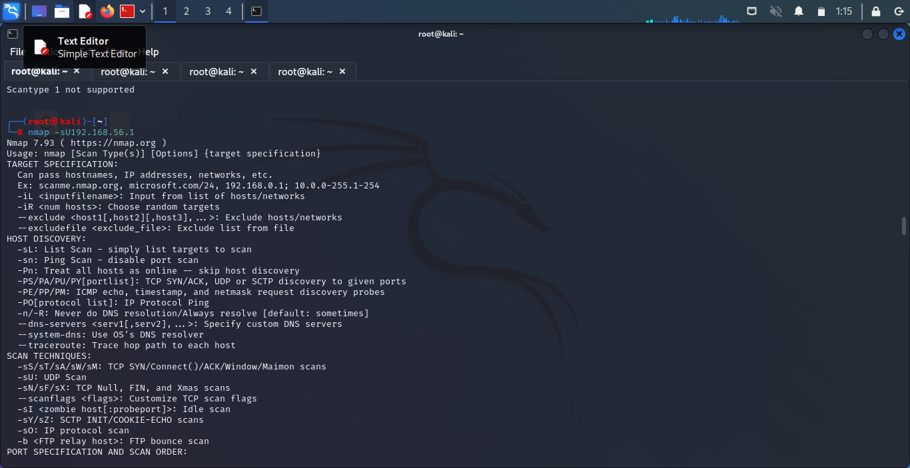

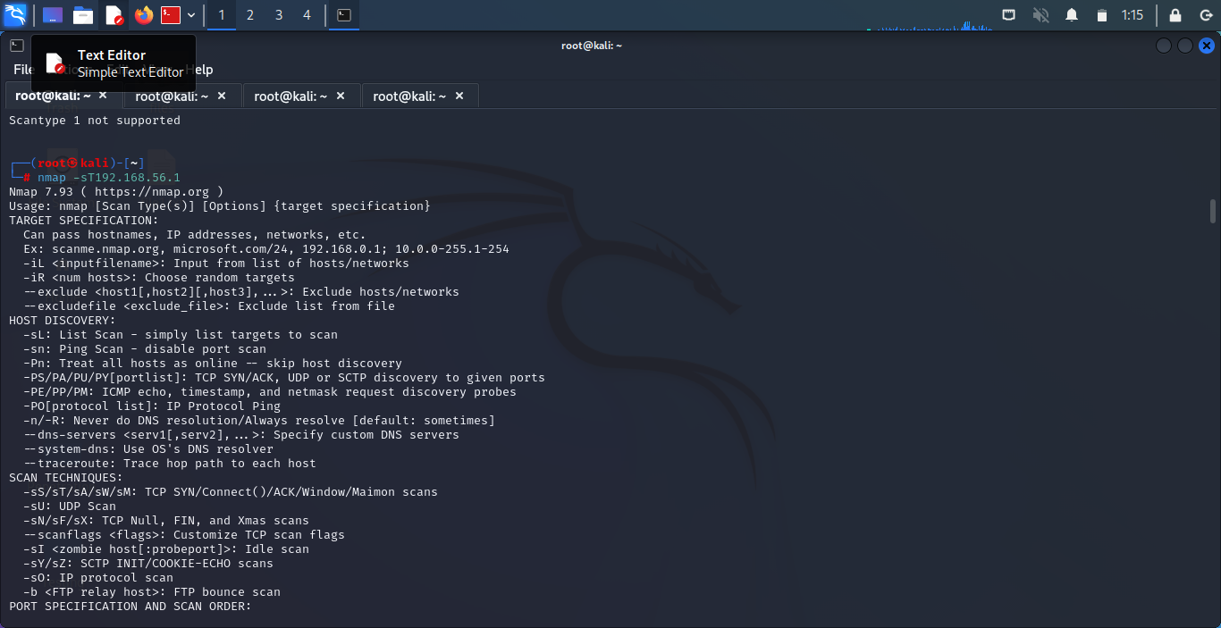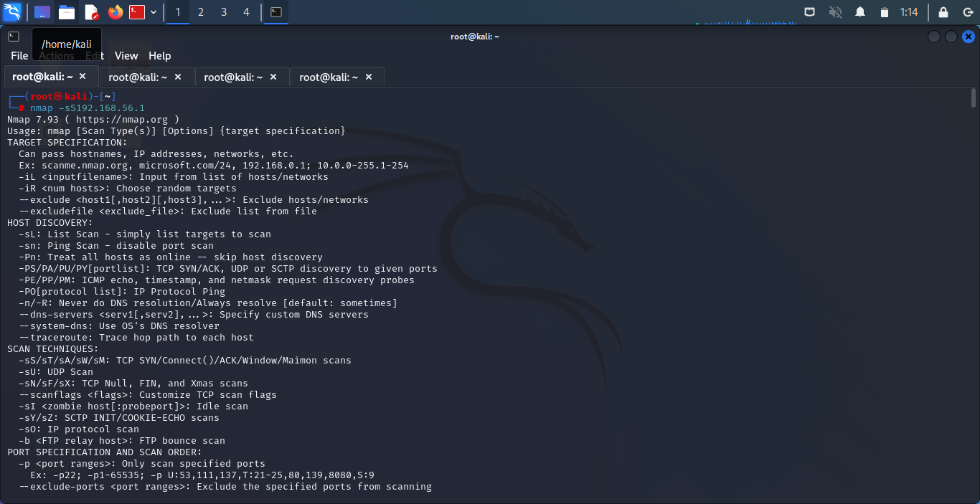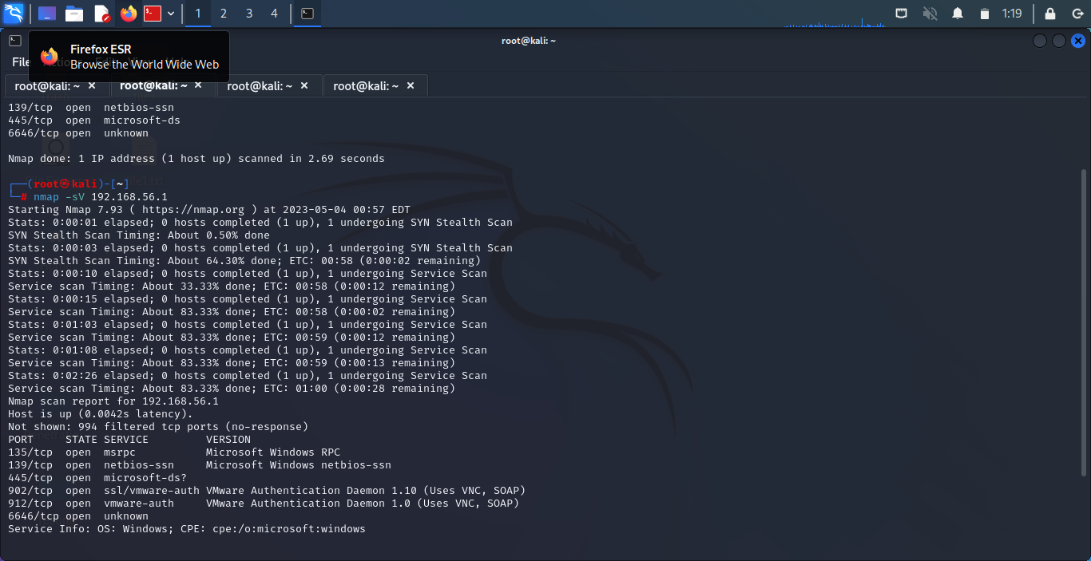

**Host Discovery**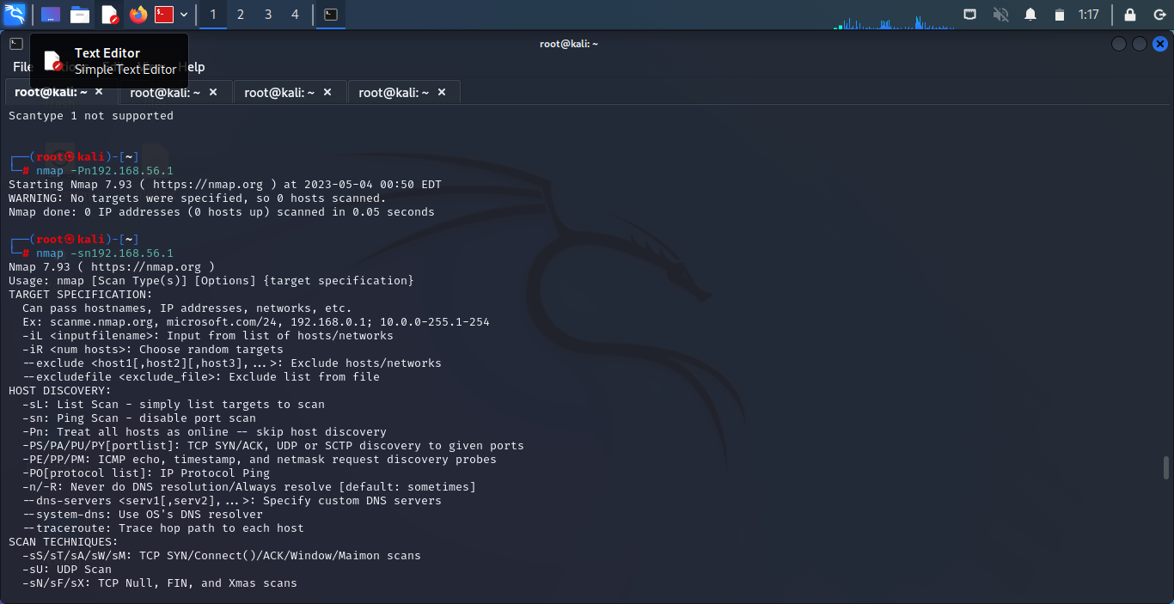

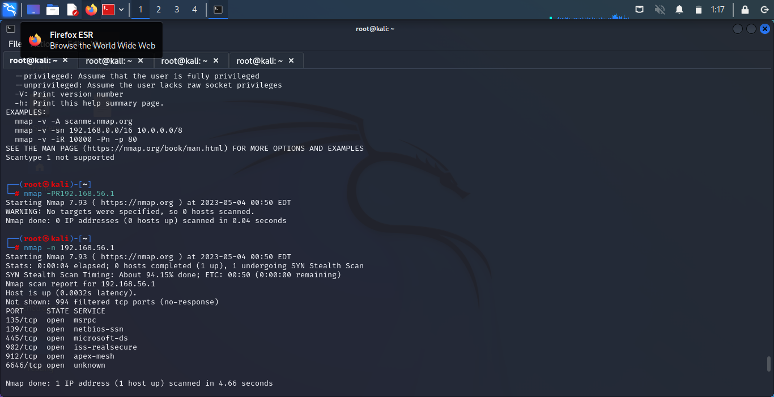

**Port Specification**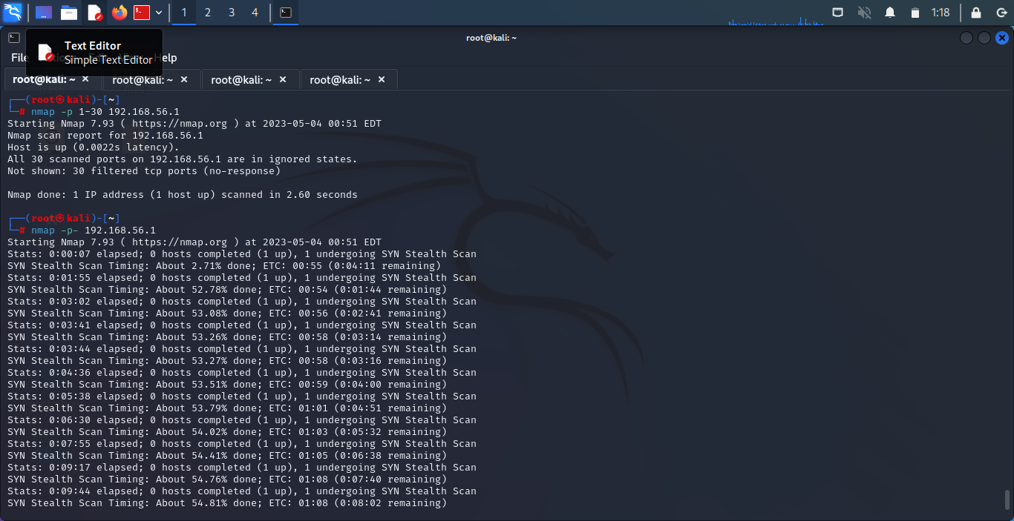

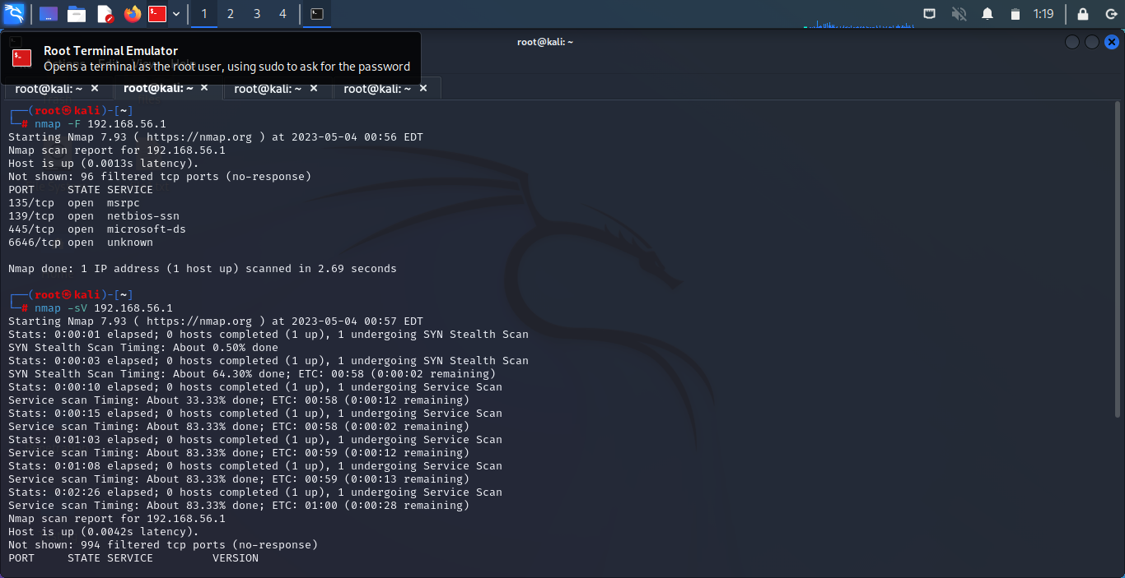**Service Version And** 

**Os Detection**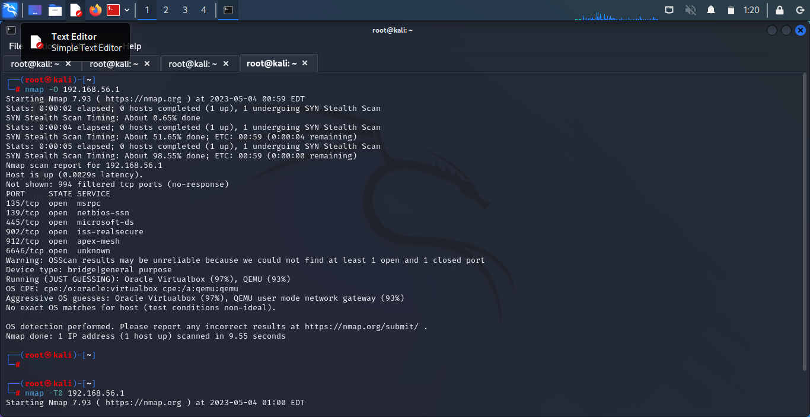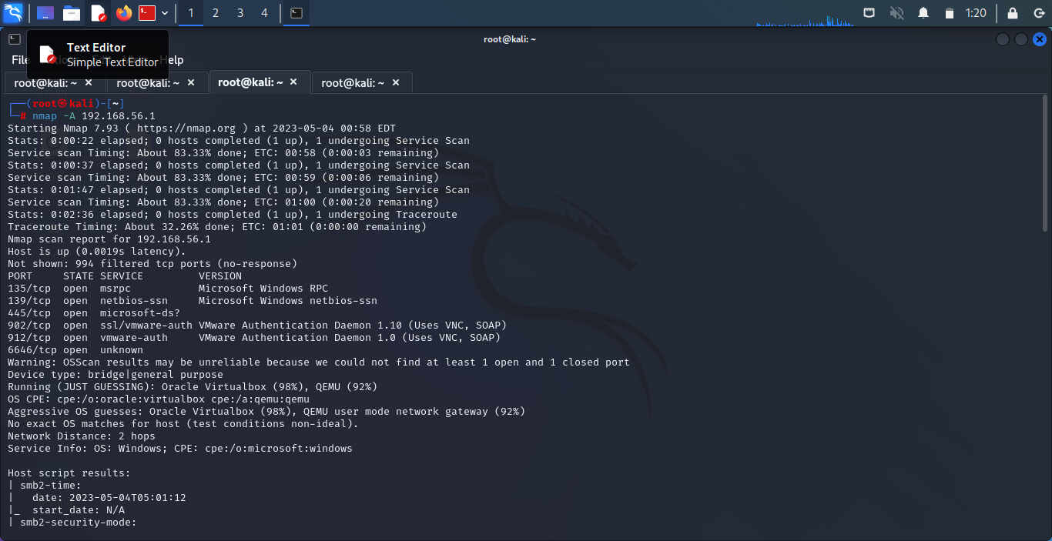

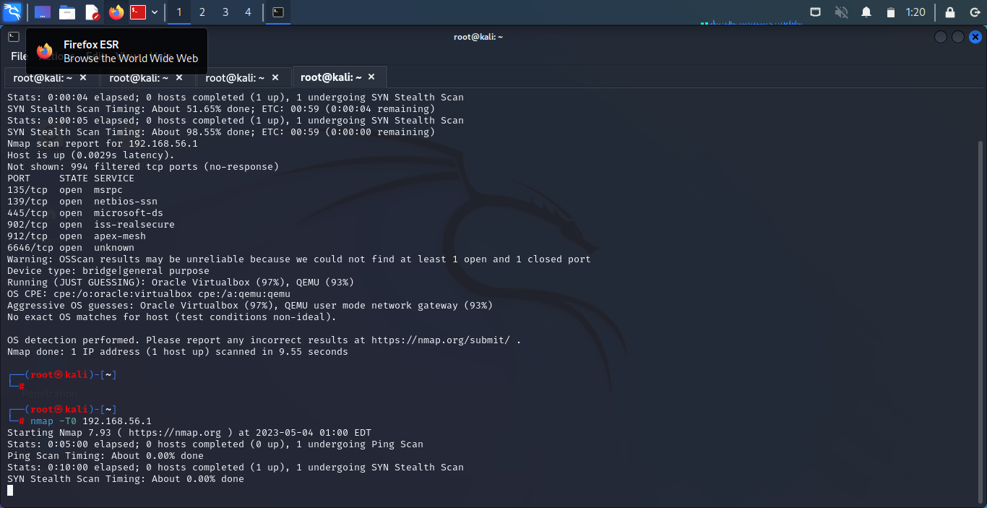**Timing And Performance** 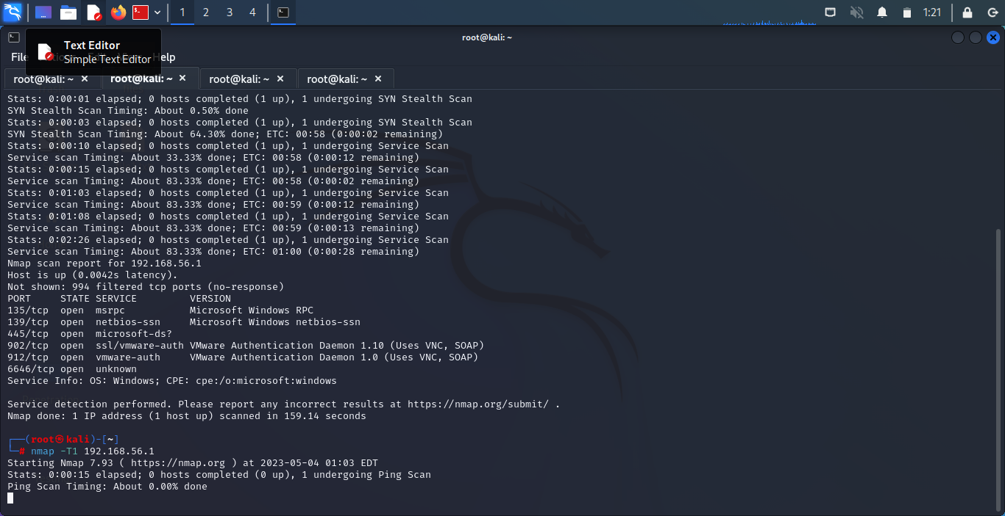

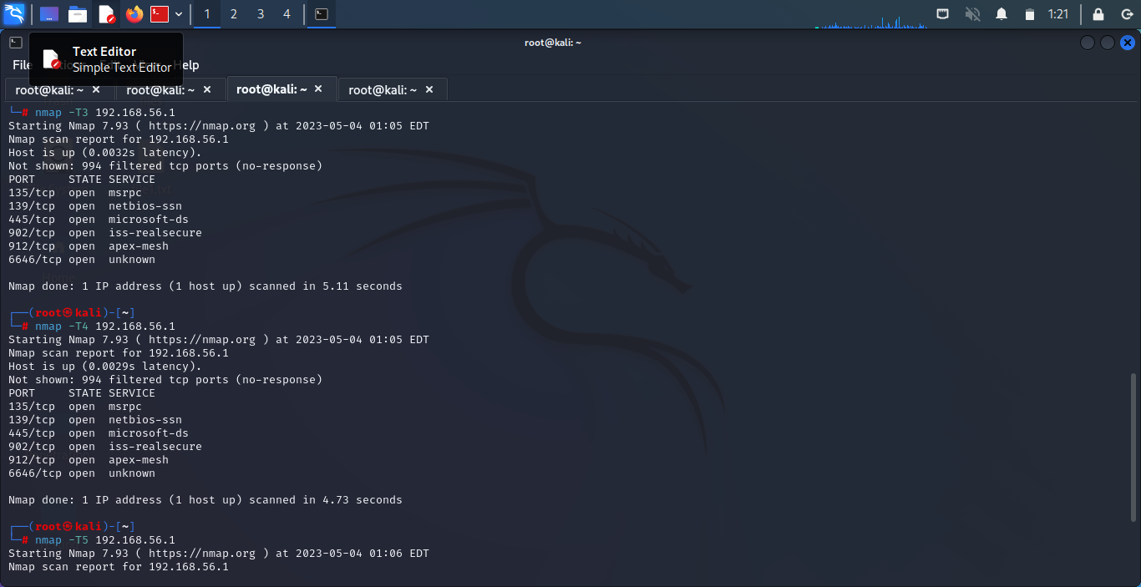

**Result :**

Hence the Nmap Scan using the KaliLinux is Performed.